**I. Project Title**

**Electric Vehicle Analytics: Understanding EV Adoption and Patterns**

**II. Project Overview**

The growing adoption of electric vehicles (EVs) is transforming transportation, energy consumption, and environmental impact worldwide. Understanding the patterns of EV ownership—who owns them, where they are located, and what types are most popular—is vital for policymakers, businesses, and researchers aiming to accelerate the transition to sustainable mobility.

This project focuses on analyzing the electric vehicle population dataset from Washington State to uncover meaningful trends, patterns, and relationships. By extracting and visualizing key insights, we aim to provide actionable knowledge to inform infrastructure planning, environmental strategies, and market opportunities.

**Focus Areas:**

* Adoption trends by make, model, and type.
* Geographic distribution of electric vehicles (county, city, state, postal code).
* Relationships between vehicle features (e.g., electric utility, CAFV eligibility, range) and adoption patterns.

**III. Problem Statement**

Electric vehicle adoption is influenced by geography, technology, and policy. However, deriving actionable insights from diverse datasets poses challenges:

* Identifying EV adoption trends across the state.
* Understanding the distribution of EV makes and models.
* Correlating EV features (electric utility, CAFV eligibility, range) with ownership patterns.

This project seeks to address these challenges by converting raw EV data into clear visualizations and actionable insights.

**IV. Project Objectives**

**Objectives:**

* Adoption Trends: Understand how EV adoption has changed over time.
* Geographic Insights: Map the distribution of EVs by city and county.
* Market Analysis: Analyze popular EV makes, models, and types.
* Make Trends: Determining what is the most owned brand of e-vehicle.

**V. Key Performance Indicators (KPIs)**

Trend Analysis:

* Accuracy in identifying EV adoption growth rates.
* Analyze EV counts by year, make, and model.
* Highlighting significant shifts over time.

Geographic Analysis:

* Clear mapping of high and low EV adoption areas.

Feature Analysis:

* Insights into the popularity of different makes/models.
* Study the distribution of EV types (e.g., BEV vs. PHEV).
* Correlate range, electric utility, and CAFV eligibility with ownership trends.

**VI. Data Sources**

**Dataset:**

This dataset shows the Battery Electric Vehicles (BEVs) and Plug-in Hybrid Electric Vehicles (PHEVs) that are currently registered through Washington State Department of Licensing (DOL).

**https://www.kaggle.com/datasets/mariusborel/electric-vhicule-population-data**

**Fields of Interest:**

* Geographic Information: County, city, state, and postal code.
* Vehicle Details: Make, model, type, range.
* CAFV Eligibility: Clean energy program eligibility.
* Electric Utility Information: Energy providers in each region.

**VII. Methodology**

Data Preprocessing:

* Load data in a schema.
* Standardize fields for consistent analysis.
* Group data by relevant categories (e.g., location, vehicle type).
* ETL processing.

Data Analysis:

* Use tools like Excel or MySQL Workbench for aggregation and visualization.
* Group data by city/county for geographic insights.
* Analyze trends using line charts, heatmaps, and bar charts.

Data Visualization:

* Line charts for trends in adoption over time.
* Maps to visualize geographic distribution.
* Bar and pie charts for market share and type distribution.

**Data Warehouse Schema:**

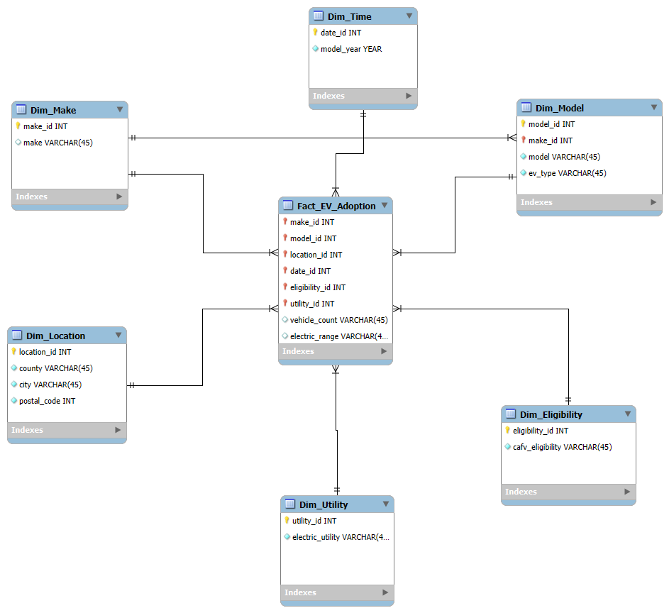

**VIII. Expected Outcomes**

* Insights into EV adoption trends across Washington State.
* Identification of high-adoption regions and their characteristics.
* Popular makes and models among EV owners.
* Correlations between EV features and adoption patterns.

**VIII. Project Leader**

* Gerald Catina

**VIV. Project Members**

* Ryan Christian Balacy Percival Callos
* Jun Micheal Roa Julius Canonio